Project Design Phase-II
Technology Stack (Architecture & Stack)

Date | 11 September 2026
Project Name | Laptop Request Management System
Maximum Marks | 4 Marks

Technical Architecture:
The Deliverable shall include the architectural diagram as below and the information as per the table1 & table 2
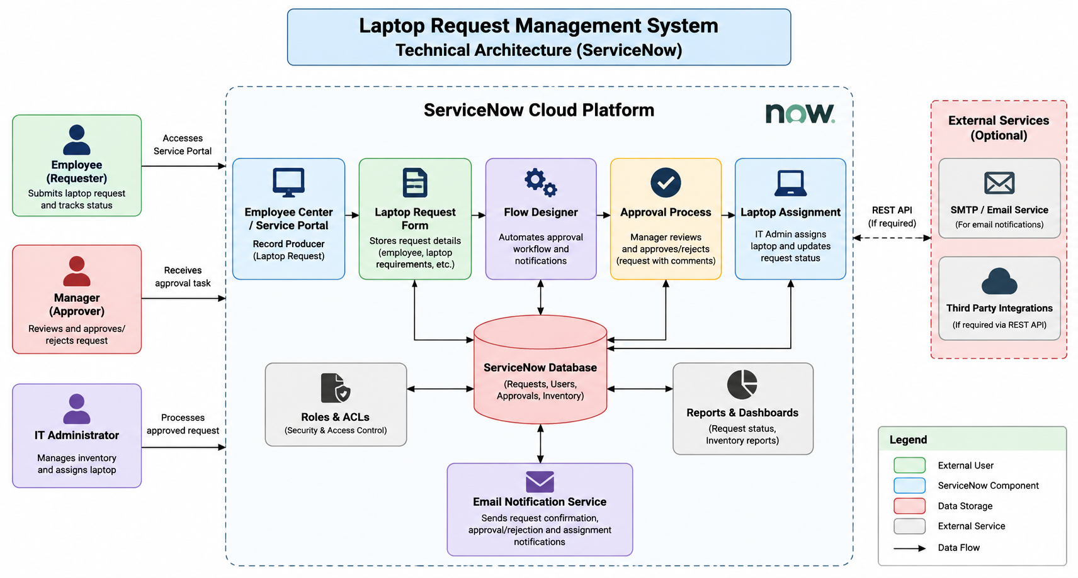

Table-1 : Components & Technologies:

S.No | Component | Description | Technology
1. | User Interface | Interface for employees, managers and IT administrators. | ServiceNow Employee Center / Service Portal
2. | Application Logic-1 | Handles laptop request creation and processing. | ServiceNow Flow Designer
3. | Application Logic-2 | Handles manager approval workflow. | Flow Designer / Approval Rules
4. | Application Logic-3 | Handles laptop assignment and status updates. | Business Rules / Flow Designer
5. | Database | Stores requests, users, approvals and laptop information. | ServiceNow Platform Database
6. | Cloud Database | Cloud-based data storage provided by the platform. | ServiceNow Cloud
7. | File Storage | Stores supporting documents and request attachments. | ServiceNow Attachments
8. | External API-1 | External integration, if required. | Not Applicable
9. | External API-2 | External integration, if required. | Not Applicable
10. | Machine Learning Model | Machine learning functionality. | Not Applicable
11. | Infrastructure (Server / Cloud) | Hosts and runs the application. | ServiceNow Cloud Platform

S.No | Characteristics | Description | Technology
1. | Open-Source Frameworks | No external open-source framework is required. | ServiceNow Platform
2. | Security Implementations | Role-based access controls protect request and inventory information. | ServiceNow Roles & ACLs
3. | Authentication | Users authenticate through the ServiceNow platform. | ServiceNow Authentication
4. | Workflow Automation | Automates approval, assignment and status updates. | Flow Designer
5. | Notifications | Sends notifications when request status changes. | ServiceNow Notifications
6. | Reporting | Provides reports and dashboards for requests and inventory. | ServiceNow Reports & Dashboards

References:
ServiceNow Documentation
ServiceNow Flow Designer
ServiceNow Access Control Lists (ACLs)

